**Assignment -3**

Build CNN Model for Classification Of Flowers

|  |  |
| --- | --- |
| Assignment Date | 30 September 2022 |
| Student Name | MUTHUPRIYA M |
| Student Roll Number | 211419104172 |
| Maximum Marks | 2 Marks |

**Question-1:**

Download the dataset

**Question-2:**

Image Augmentation

**Solution**

from tensorflow.keras.preprocessing.image import ImageDataGenerator

train_datagen=ImageDataGenerator(rescale=1./255,zoom_range=0.2,horizontal_flip=True,vertical_flip=True)

test_datagen=ImageDataGenerator(rescale=1./255)

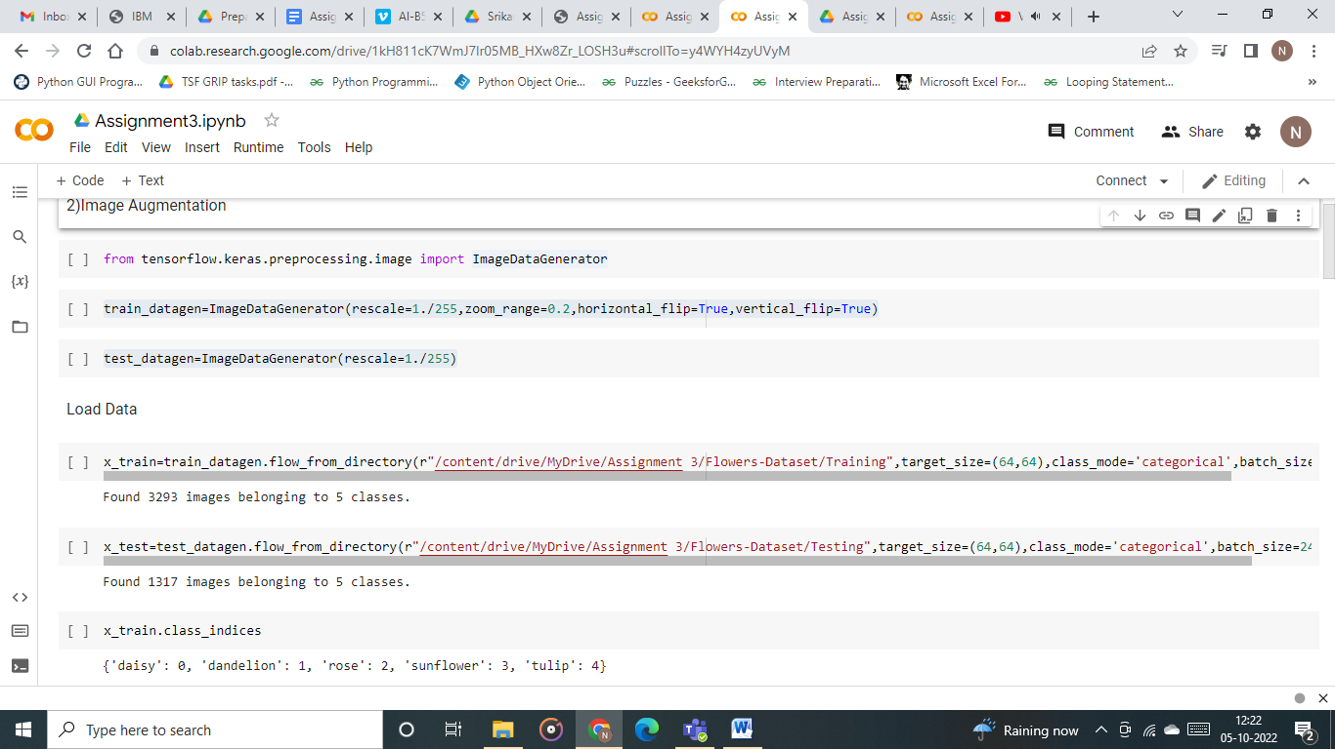

**Question-3:**

Create model

**Solution**

from tensorflow.keras.models import Sequential

from tensorflow.keras.layers import Dense,Convolution2D,MaxPooling2D,Flatten

model=Sequential()

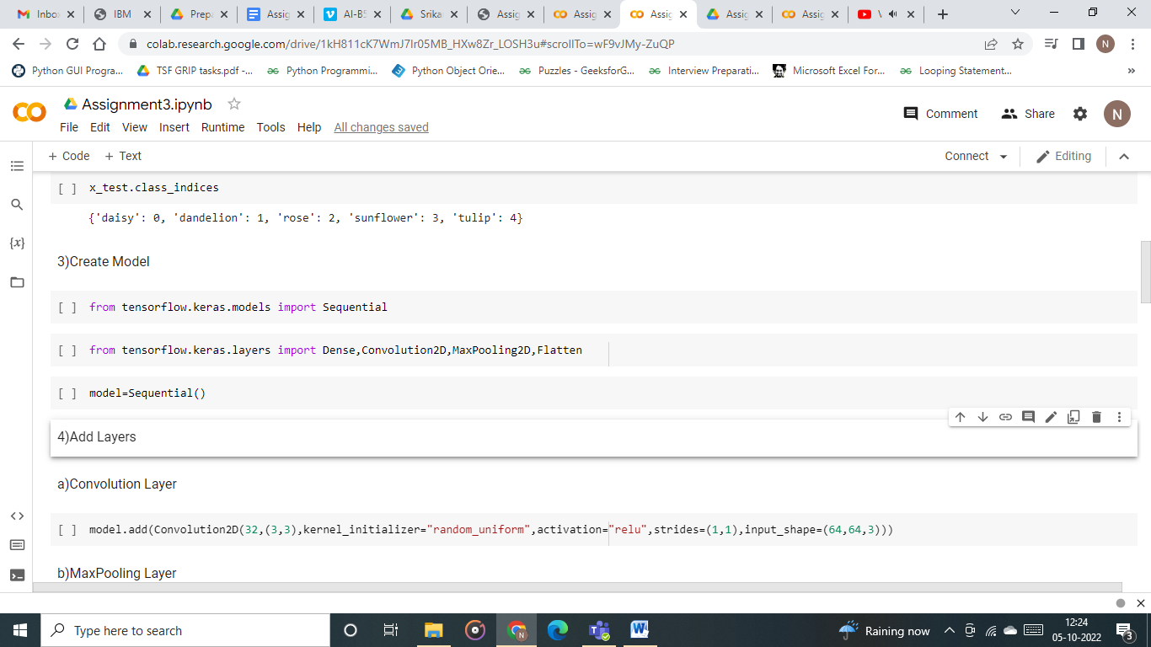

**Question-4:**

Add Layers (Convolution,MaxPooling,Flatten,Dense-(Hidden Layers),Output)

**Solution**

**a)Convolution Layer**

model.add(Convolution2D(32,(3,3),kernel_initializer="random_uniform",activation="relu",strides=(1,1),input_shape=(64,64,3)))

**b)MaxPooling Layer**

model.add(MaxPooling2D(pool_size=(2,2)))

**c)Flatten Layer**

model.add(Flatten())

**d)Dense(Hidden layer)**

model.add(Dense(300,activation="relu"))

model.add(Dense(300,activation="relu"))

**e)Output layer**

model.add(Dense(5,activation="softmax"))

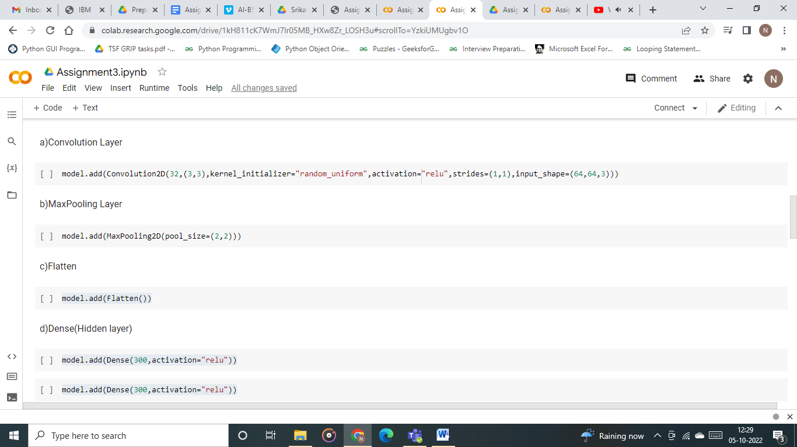

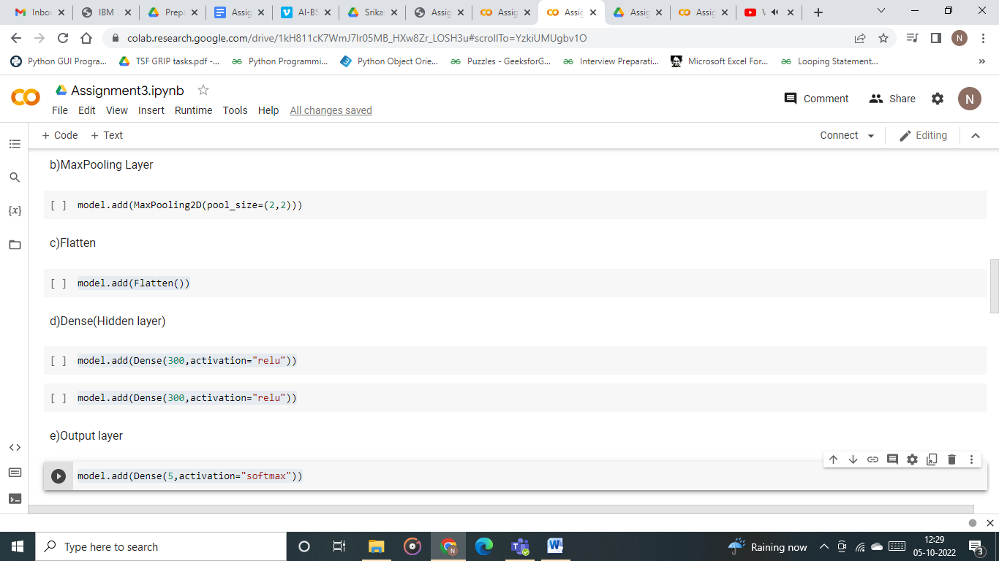

**Question-5:**

Compile The Model

**Solution**

model.compile(loss="categorical_crossentropy",metrics=['accuracy'],optimizer='adam')

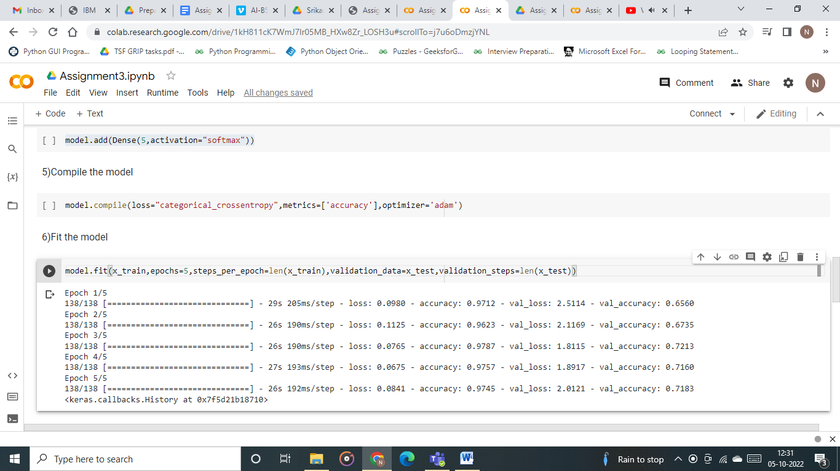

**Question-6:**

Fit The Model

**Solution**

model.fit(x_train,epochs=5,steps_per_epoch=len(x_train),validation_data=x_test,validation_steps=len(x_test))

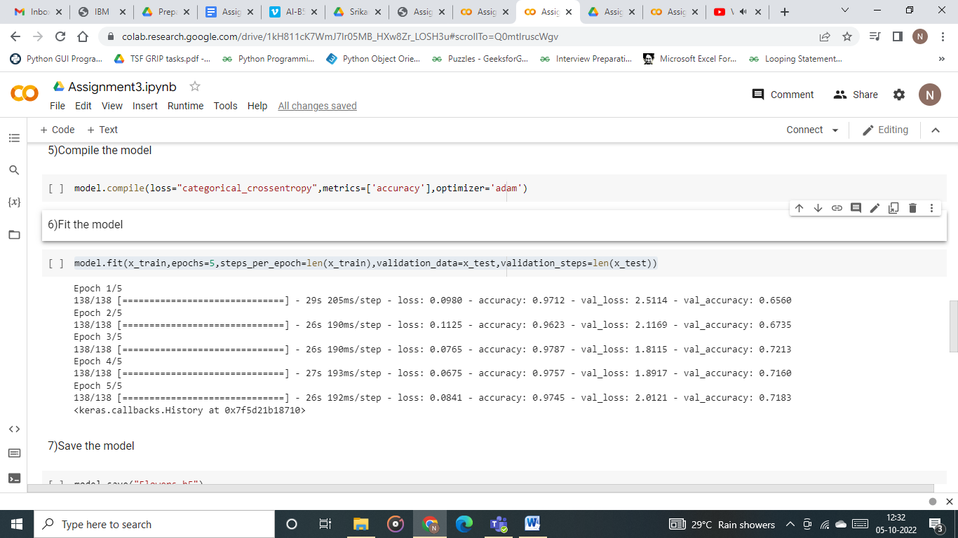

**Question-7:**

Save The Model

**Solution**

model.save("Flowers.h5")

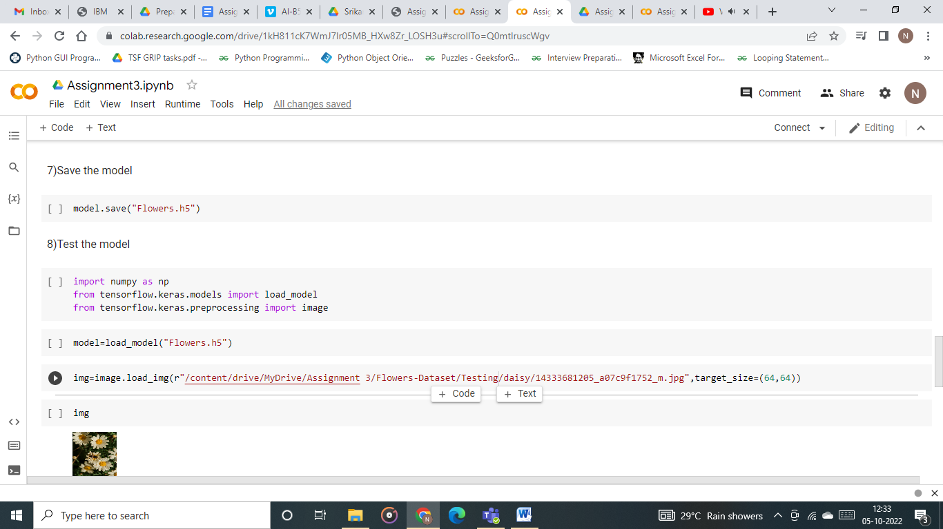

**Question-8:**

Test The Model

**Solution**

import numpy as np

from tensorflow.keras.models import load_model

from tensorflow.keras.preprocessing import image

model=load_model("Flowers.h5")

img=image.load_img(r"/content/drive/MyDrive/Assignment 3/Flowers-Dataset/Testing/daisy/14333681205_a07c9f1752_m.jpg",target_size=(64,64))

x=image.img_to_array(img)

x=np.expand_dims(x,axis=0)

pred=model.predict(x)

pred

index=['daisy','dandelion','rose','sunflower','tulip']

index[np.argmax(pred)]

